FIT5145: Foundations of Data Science
Assignment 3 (Report)
Name: Bharath Arun Gandhimani Student ID: 35501308

Type of GenAI Used: ChatGPT (OpenAI) and Google Gemini

Purpose of Use:
Methodology Selection Support: Consulted ChatGPT for guidance on selecting and interpreting a suitable machine learning method (Random Forest) for predictive modeling.
Writing Structuring and Clarity Improvement: Assisted in refining report organization, ensuring coherent section flow and concise wording under the 2500-word limit.
All analytical code, data processing, visualizations, and interpretations were performed independently using R within the R Markdown environment.

Have you selected a topic different from Assignment 1?
Yes, the topic for this report extends beyond the original proposal by incorporating predictive modeling using Random Forest techniques alongside detailed exploratory data analysis of Max Verstappen’s performance in Formula 1 from 2015 to 2024. This represents a development from strategic insights toward performance prediction and validation.

Feedback from Assignment 1
Assignment Marker: Jesmin Nahar
- Problem Clarity: Could have related references to establish your arguments.
- Business Model Analysis: (no specific comment)
- Problem Importance: Project addresses real-world challenges in motorsport and demonstrates potential social/commercial impact. Applications beyond F1 add value, but broader societal impact is moderate.
- Novelty: Approach is novel (driver-specific, open-data focused, transferable), but methods are incremental adaptations rather than fully groundbreaking.
- Peer grading: Well done.
How did you incorporate this feedback to improve your Assignment 3 submission?
Based on Jesmin Nahar’s feedback, I strengthened Assignment 3 by integrating academic and industry references to support key arguments and clarify problems. The business model and value proposition were expanded to show how the analysis benefits diverse stakeholders and demonstrates the broader value of open data analytics beyond motorsport. The introduction now better defines the project’s objectives and real-world relevance, while the novelty section highlights its distinctive driver-focused perspective and transparent data approach. Analytical methods remain iterative but are now explicitly justified, reflecting purposeful improvement in scope and presentation. Overall, these revisions enhance clarity, originality, and academic rigor within the data science discipline.

Introduction
Formula One (F1) represents the peak of motorsport, where marginal performance differences decide outcomes. The sport’s growing digitization has created vast datasets spanning race results, lap times, pit stops, and circuit features. This project focuses on Max Verstappen, aiming to deliver data-driven strategies to enhance future performance. It integrates diverse race data to explain and predict performance variability influenced by circuit type, competitor strength, seasonal trends, and conditions. This analysis matters because teams and sponsors depend on predictive insights to refine race strategy, driver preparation, and resource use for competitive advantage.
The specific goals of this project are to:
- Characterize and analyze the factors influencing Max Verstappen’s finishing positions across races, identifying key performance drivers from grid positions, pit stops, and qualifying sessions.
- Develop a predictive model to understand and forecast race outcomes using explanatory features such as qualifying gap, pit stop strategy, constructor momentum, and race environment variables.
- Quantify relationships between operational metrics and results, such as average pit stop duration, lap time consistency, and finish positions, to identify efficiency patterns in Red Bull’s race management.
- Examine temporal performance trends by incorporating rolling averages of recent finishes and constructor points, providing an understanding of form momentum across seasons.
- Visualize and interpret race patterns through extensive exploratory data analysis, producing clear graphical insights (histograms, regression trends, boxplots, and correlation matrices) to assist human interpretation of performance drivers.
- Validate model performance using statistical measures (RMSE, MAE, and $R^{2}$) for both training and test data, ensuring reliability and generalizability of the results.
- Apply predictive modeling dynamically, demonstrating practical use through forecasting for future races (e.g., the 2025 Italian Grand Prix), emphasizing the feasibility of data-driven strategy support.

Related Work
- F1 analytics is well-established, with teams investing in telemetry and machine learning to refine strategy. Prior research such as Koh (2024) has analyzed historical race outcomes to identify top drivers, constructors, and pit stop influences primarily via descriptive techniques. Predictive models often rely on proprietary datasets combined with complex simulations not publicly accessible.
- This project differentiates itself through three novelties:
  - Driver-Centric Focus: Examines Verstappen’s performance across rivals and circuit types rather than broad aggregates.
  - Use of Open Data: Applies advanced predictive analytics to publicly available Kaggle datasets, democratizing insights typically locked behind paywalls.
  - Context-Specific Analysis: Builds models integrating variables such as grid position, qualifying gap, pit stop metrics, constructor form, driver momentum, and circuit features (altitude, latitude, longitude). These predictors capture both race-specific and environmental contexts, revealing how performance evolves with track conditions, team dynamics, and strategy.

Business Model

Stakeholders
The primary stakeholders who benefit from this assessment are:
- Drivers & Race Engineers -> to refine pre-race preparation and in-race decision-making.
- Team Strategists (Red Bull Racing) -> to optimize pit-stop timing, tire strategy, and rival analysis.
- F1 Management & Sponsors -> to highlight performance narratives that can engage fans and improve brand value.
- Fans & Media Analysts -> to access deeper, more engaging insights about race strategy beyond surface-level statistics.

Value Proposition
This assessment aims to unlocks the hidden value of publicly available Formula 1 data by providing strategic insights that are typically confined to team’s proprietary telemetry systems. By categorizing circuits, benchmarking rival performance, and visualizing pit stop patterns, the project addresses several real-world challenges in motorsport:
- Strategic Decision-Making for Teams
  - The analysis highlights conditions under which drivers like Max Verstappen can gain a competitive edge, offering teams actionable intelligence without the high cost of proprietary simulation systems. For instance, knowing how rivals typically underperform on street circuits or during specific pit stop windows can inform race-day strategy and improve the probability of victory.

- Bridging the Data Gap for Sponsors and Stakeholders
  - Sponsors often lack access to the granular performance data that teams guard closely. By providing digestible insights from open data, this project allows sponsors to better align their branding with performance narratives (e.g., associating with reliability, adaptability, or dominance on specific track types), ultimately enhancing return on investment.
- Scalable Applications Beyond Motorsport
  - The methodology-using open data to uncover patterns in performance and decision-making-has broader implications for other industries where high-cost proprietary analytics create barriers. This showcases how transparent, data-driven insights can level the playing field, reduce reliance on closed systems, and drive innovation.
- Societal Impact
  - By making advanced performance analytics accessible using open data, the project helps democratize knowledge that is normally siloed within elite, resource-rich organizations. This approach empowers students, educators, independent analysts, and fans to engage deeply with motorsport analytics, fostering STEM learning and data literacy in broader society.
In doing so, this assessment not only advances competitive fairness within Formula 1 but also illustrates how open-data science can have social and commercial impact in other data-intensive fields.

Characterizing and Analyzing Data

Data Sources and Characteristics
The primary dataset is the Formula 1 World Championship dataset (1950–2024) from Kaggle, comprising detailed race results, driver stats, lap times, pit stops, and circuit metadata.
- Volume: The dataset spans over seventy years of racing history, encompassing thousands of records capturing race-by-race granularity for multiple attributes per driver and constructor.
- Variety: The data integrates diverse formats such as numerical timing metrics, categorical identifiers (driverId, constructorId), text (race names), and geospatial variables (circuit altitude, latitude, and longitude).
- Velocity: The data is static and historical; no streaming or real-time ingestion is required.
- Veracity: The data is cleaned rigorously to handle missing values (encoded as "\N" or blanks) and convert character timings to numeric forms ensuring quality analysis.

Platforms, Software, and Tools
Data processing uses R and R Markdown for reproducibility, visualization (ggplot2), and modeling (randomForest). The combination offers flexibility for statistical computing, visualization, and report generation. The workflow is scalable with relational joins handling multi-table data, and modeling adapts for non-linear effects critical in sports analytics.

Data Analysis Techniques and Statistical Methods
- EDA using correlation matrices, histograms, scatterplots, and smoothing lines identified key predictors of finishing position, including grid position, qualifying gap, pit stop efficiency, and recent constructor points.
- Random forest regression was chosen for its robustness to nonlinearity, mixed data types, and overfitting resistance. It captures complex feature interactions (e.g., qualifying gaps with pit stop strategies) better than linear models, matching the multifactor nature of racing outcomes.
- The expected result is a predictive model estimating finishing positions and supporting strategic race simulations.

Demonstration
To demonstrate the feasibility and validity of the proposed data science approach for understanding and predicting Max Verstappen’s Formula 1 race performance, a comprehensive analysis is conducted using the Kaggle Formula 1 World Championship dataset (1950–2024). This section details the preliminary exploratory data analysis, data cleaning, feature engineering, modeling, predictions, and key findings from the analytical process.

Preliminary EDA (Before Feature Engineering)
An initial exploratory data analysis was performed prior to feature engineering to examine relationships among key race-related variables and to identify meaningful predictors for modeling.
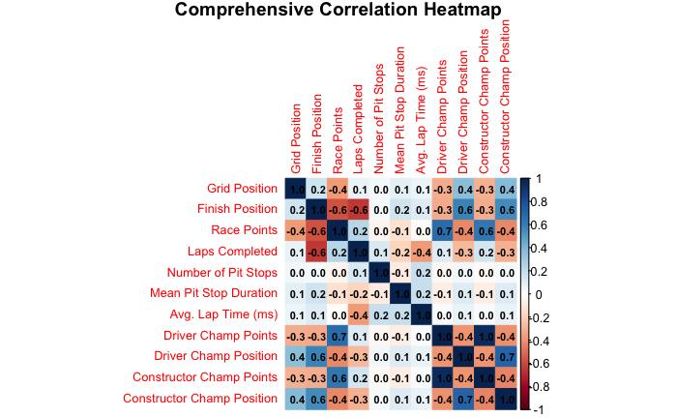
- Grid Position vs. Finish Position: A moderate positive correlation (about 0.2), meaning drivers starting closer to the front grid tend to finish nearer the front, but start position isn’t everything.
- Finish Position vs. Race Points: A strong negative correlation (approx -0.8). This makes sense: lower (better) finishing positions yield more points in F1 scoring (P1 > P2 >) .
- Race Points and Championship Points: Strong positive relationships (0.7+), as more race points lead to increased season points for both drivers and constructors.
- Championship Points vs. Championship Position: Strong negative correlation (approx -0.8), as more points mean a better (lower) ranking.
These findings directed which variables were retained and engineered in subsequent stages to ensure only meaningful, non-redundant predictors were included.

Data Cleaning and Preparation
Datasets were imported into the R environment and standardized using helper functions. Missing values encoded as “\N” or blanks were recoded to NA for consistency.
Key transformations included converting time strings (e.g., “1:26.000”) into numeric seconds and ensuring correct categorical identifiers for merging multiple data sources.

Feature Engineering
To capture both driver strategy and contextual effects particular to Max Verstappen's performance, new predictive features were computed exclusively from his race and qualifying data. These features aimed to characterize Verstappen's competitive profile and race conditions impact:
- Best Qualifying Lap (sec): For each race, Verstappen’s fastest valid qualifying lap was calculated by taking the minimum among his q1, q2, and q3 times.
- Pit Stop Metrics: The total number of pit stops and their average duration for Verstappen per race were summarized to reflect his pit strategy and efficiency.
- Average Lap Time (ms): Verstappen’s mean lap time per race was computed to approximate his race pace and consistency.
- Rolling Averages: Rolling three-race averages of Verstappen’s recent finishing positions and constructor points illustrated his form momentum over time.
- Qualifying Gap (qgap): His qualifying time gap relative to the race pole position was calculated as a measure of starting grid competitiveness.

Exploratory Data Analysis (Post-Feature Engineering)
After constructing a comprehensive set of engineered features focused on Max Verstappen’s race and qualifying performance, further detailed exploratory data analysis confirmed several important insights:
- Dominance of Grid Position and Constructor Points: The correlation matrix revealed a strong and consistent influence of Verstappen’s grid position on his finishing position. Starting near the front substantially increases the likelihood of a podium or race win.
- Positive Correlation Between Qualifying Gap and Finish Position:
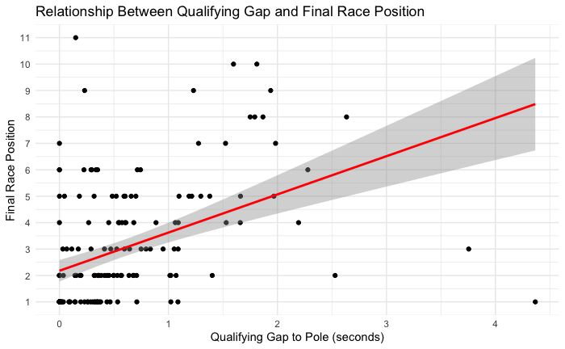
Visualizations plotting Verstappen’s qualifying gap shows that the time difference from the pole position lap against his finishing position illustrates a clear upward trend. Smaller gaps correlated with top finishes, confirming that qualifying performance is a key predictor of race success. However, the data also showed exceptions where Verstappen overcame larger qualifying gaps through superior racecraft or strategy.

- Complex Pit Stop Strategy Relationships:
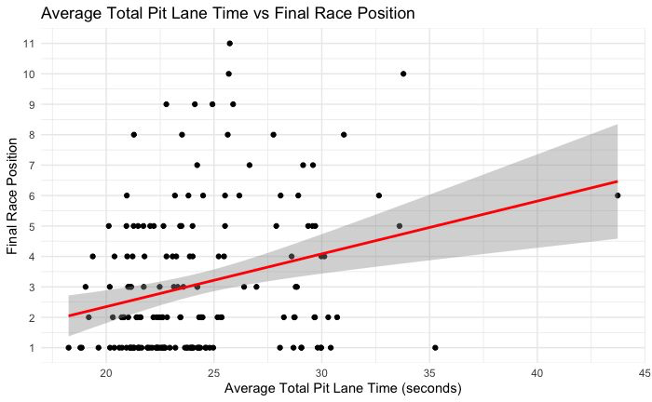
Pit stop metrics such as the number of stops and average pit stop duration exhibited intricate patterns. Most races involved one or two pit stops, but some races with multiple stops or longer average pit durations still resulted in wins. This indicates that while efficient pit stops generally improve race outcomes, Verstappen’s skill and tactical decisions can mitigate less optimal pit scenarios.

- Influence of Recent Driver Form (Rolling Mean Finish Position):
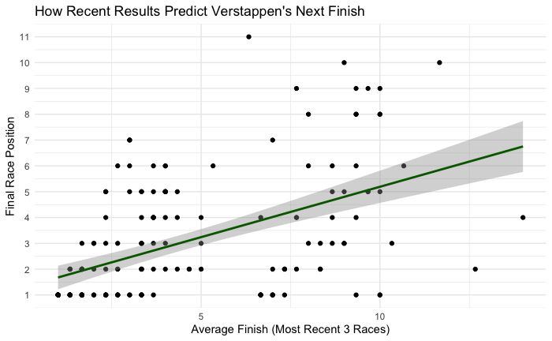
A particularly strong relationship emerged between Verstappen’s average finish over the previous three races and his subsequent race result. This rolling mean finish position proved to be a valuable predictor of near-term performance, indicating that momentum and consistency significantly contribute to race outcomes. The trend suggests that Max Verstappen’s recent performance trajectory is a critical context factor shaping his success, reflecting both psychological confidence and stable operational conditions.

Train-Test Split and Model Design
The final dataset was split into 80% training data and 20% test data, ensuring representative coverage. Missing values were imputed with median values from the training set.
Predictors included grid, squared grid, qualifying gap, pit stop count and duration, recent constructor form, constructor wins, recent driver finishes, altitude, latitude, longitude, and temporal features (year and round).

Model Training and Evaluation
A random forest regression model was trained using repeated 5-fold cross-validation to optimize predictive accuracy and reduce overfitting, selecting RMSE as the tuning metric.
The model performed well, achieving low root mean squared error and mean absolute error on both training and test data, as well as high R-squared values indicating strong explanatory power.
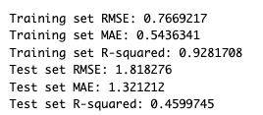
Residuals showed limited error variance, primarily due to unpredictable race events.

Prediction for the 2025 Italian Grand Prix
Using the trained model, prediction was made for Verstappen’s expected finishing position at the 2025 Italian Grand Prix, incorporating inputs like starting grid position (2), qualifying gap (75.5 seconds), two pit stops averaging 2.5 seconds, constructor points, recent form, and circuit characteristics from Monza.
The model predicted a finishing position near 2.76, suggesting a podium finish or likely victory. (He got 1st place in the actual race).

Goodness-of-Fit: Visualization
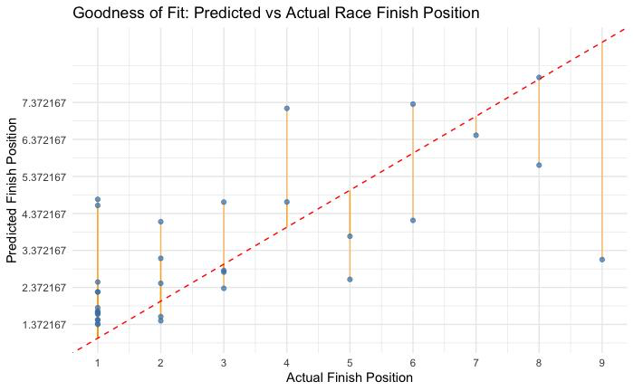
- The goodness-of-fit plot demonstrates that the model predicts Max Verstappen’s finish positions with reasonable accuracy.
- Most predicted values for high finishes (like 1st or 2nd) are close to the actual results, clustering near the red dashed identity line, though the model is less precise for lower finish positions.
- The spread of points about the line highlights that while the model captures dominant winning tendencies well, there is greater error and variability when Verstappen finishes further down the order, reflecting both the model’s strengths in forecasting top results and its limitations in rare, less typical race scenarios.

Standards for Data Science Process, Governance, and Management
- Standards: The process follows standard data science workflows such as data acquisition, cleaning, exploratory analysis, modeling, validation, and reporting with transparency and reproducibility using R Markdown.
- Data Governance: Data used is open and publicly available, minimizing concerns around confidentiality. Data accessibility is preserved by sharing code and dataset links.
- Security: As no sensitive personal or proprietary data is processed, security risks are low. All data access complies with Kaggle terms and ethical use.
- Ethical Concerns: The project ensures fairness by focusing on publicly accessible data and avoids misuse of proprietary team telemetry; insights promote transparency rather than competitive secrecy.
- Management: Version control (e.g., Git) and reproducible documents enforce process discipline and traceability.

References
- Rao, R. (2025). Formula 1 World Championship (1950-2024) [Dataset]. Kaggle. https://www.kaggle.com/datasets/rohanrao/formula-1-world-championship-1950-2020
- Breiman, L. (2001). Random forests. Machine Learning, 45(1), 5–32. https://www.stat.berkeley.edu/~breiman/randomforest2001.pdf
- Ditroilo, M. (2025). Exploratory research in sport and exercise science. Journal of Sports Sciences. https://www.tandfonline.com/doi/full/10.1080/02640414.2025.2486871
- Kuhn, M. (2008). Building Predictive Models in R Using the caret Package. Journal of Statistical Software, 28(5). https://www.jstatsoft.org/article/view/v028i05
- Weissbock, J., & Mills, S. (2025). Evaluating the predictive power of qualifying performance in Formula One Grand Prix. arXiv Preprint. https://arxiv.org/html/2507.10966v1
- R Core Team. (2024). R: A Language and Environment for Statistical Computing. Vienna, Austria: R Foundation for Statistical Computing. https://www.R-project.org/
- Cole, N. L. (2024). The societal impact of open science: A scoping review. PLoS ONE, 19(6), e261965. https://doi.org/10.1371/journal.pone.0261965Ditroilo, M. (2025).

